GIT HISTORY

Brian Colantonio - 2018 Capstone

(abandoned first attempt)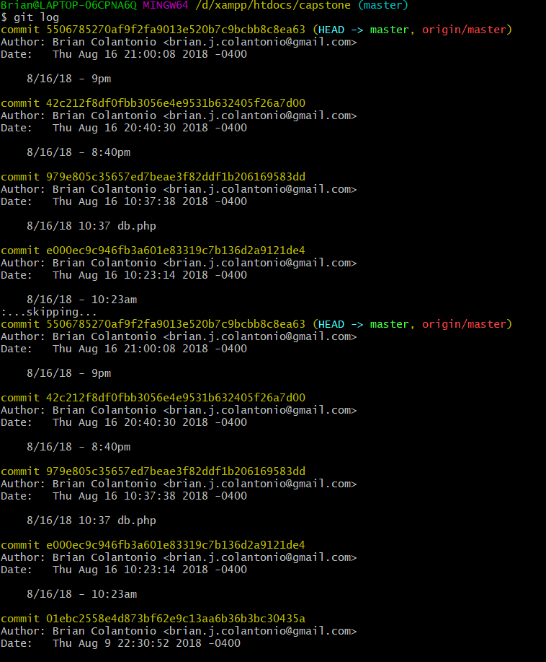

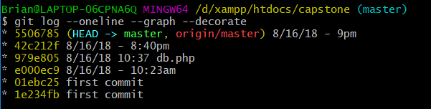

Current functioning application